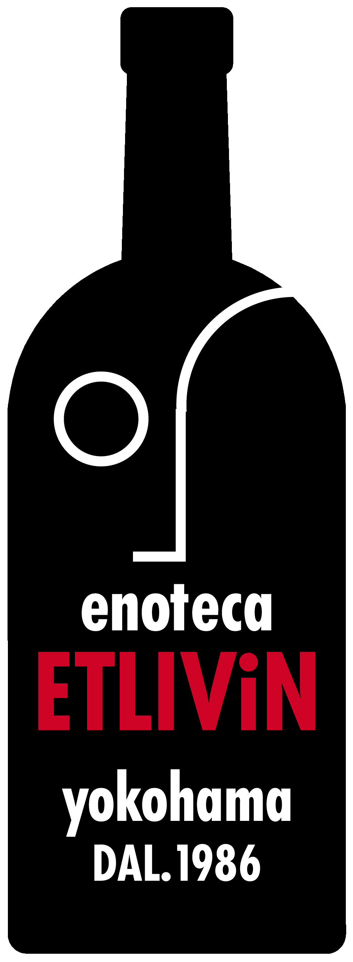
EWC – Etlivin s.r.l.

Bronze V.d.T.

