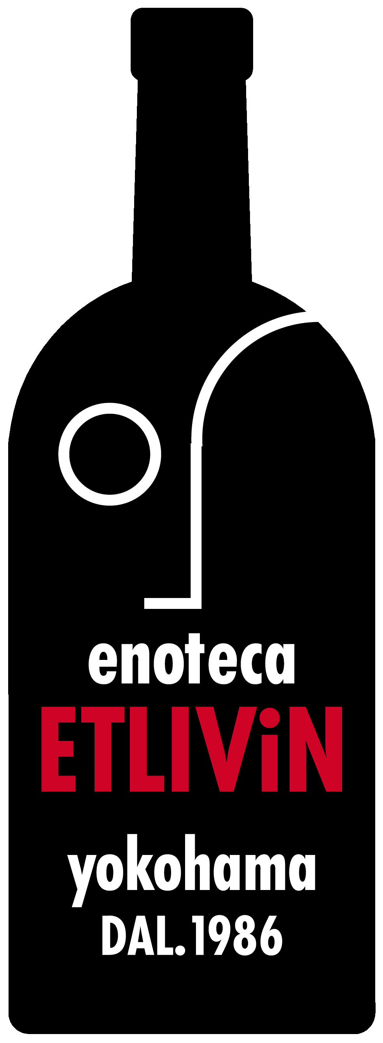
EWC – Etlivin s.r.l.

Silver i.g.t.
EWC – Etlivin s.r.l.

Bronze v.d.t.

EWC – Etlivin s.r.l.

EWC – Etlivin s.r.l.

Platinum d.o.c.g.
EWC – Etlivin s.r.l.

Gold d.o.c.

